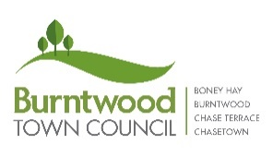
Burntwood Town Council
Application for the Better Burntwood Fund (funding of up to £500)

Burntwood Town Council is committed to assisting local organisations and groups that provide activities and support to the local community.
Any amount given will be proportionate to the public benefit and must be relevant to the area.
Please provide as much detail as possible and refer to the Guidance Notes and Conditions of Funding before submitting this form.
Name of Organisation

Address

Email

Main telephone No.

Overview of your organisation including objectives, and membership numbers (how many members live in Burntwood Parish):

Type of organisation:

❑ Informal group
❑ Registered Charity. Registered Charity Number __________________
❑ Society or Club with Adopted Constitution
❑ Community Interest Company
❑ Company Limited by Guarantee
❑ Local branch of a national organisation
❑ Other (please specify) ________________________________________

Have you received any other funding within the last 12 months?:

Describe your project and the support you require:
Additional sheet attached □

Funding breakdown and total amount requested:
Item | Amount
 | Total:

Who are the project beneficiaries? How will this benefit Burntwood residents?:

❑ A recent statement of accounts is attached.
❑ A copy of our constitution is attached.
❑ If successful we agree to appearing in publicity about the funding received across platforms such as Burntwood Town Council’s social media channels and website, and in the local media.
❑ If successful we agree to acknowledging Burntwood Town Council in any publicity relating to the activity for which the funding has been given.

❑ If successful we agree to providing Burntwood Town Council with an update on the outcome of the activity when requested.

By signing and submitting it is accepted that all the above facts are correct, and the funds will only be used for the stated purpose:
Signature

Print Name

Date

Please return to: Burntwood Town Council, The Old Mining College, Queen Street, Burntwood WS7 4QH or email jayne.minor@burntwood-tc.gov.uk.

